**UNIX File System & Permissions**

**1: Give the execute permission for the user for a file chap1.**

**2: Give execute permission for user, group and others for a file add.c**

**3: Remove the execute permission from user, give read permission to group and others for a file aa.c**

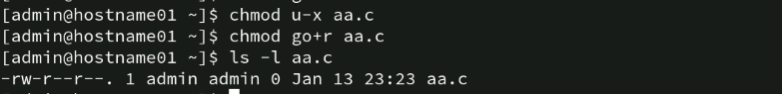

**4: Give execute permission for users for a.c, kk.c, nato and myfile using single command.**

**5: Change the directory to root directory. Check the system directories, like bin, etc, usr etc.**

**Using Pipes and Filters**

**1: Redirect the content of the help document ls, into a file called as lsdoc.**



**2: Display the content of the lsdoc page wise.**

**[admin@hostname01 ~]$ less lsdocs**

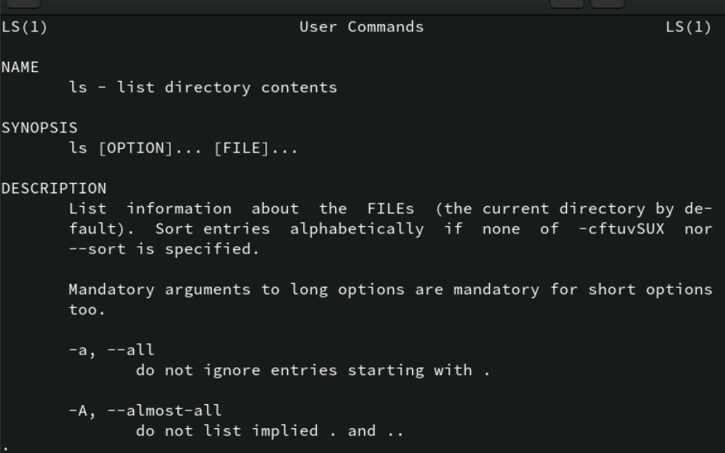

**3: Display only the first 4 lines of the lsdoc file.**

**4: Display only the last 7 lines of the file lsdoc.**

**5: Remove the file lsdoc.**



**6: There will be B’day celebration from the friends file, find how many B’day parties**

**will be held. If two of the friends have the B’date on the same day, then we will be**

**having one party on that day.**

**7: Display the lines starting with Ma, in the file friends.**

**[admin@hostname01 ~]$ grep “^Ma” friends.txt**

**8: Display the lines starting with Ma, ending with i or ending with id, in the file friends.**

**[admin@hostname01 ~]$ grep “^Ma.*\(i\|id\)$” friends.txt**

**9: Print all the files and the directory files from the current directory across all the sub directories, along with its path**

**10: Print only the Directory files.**

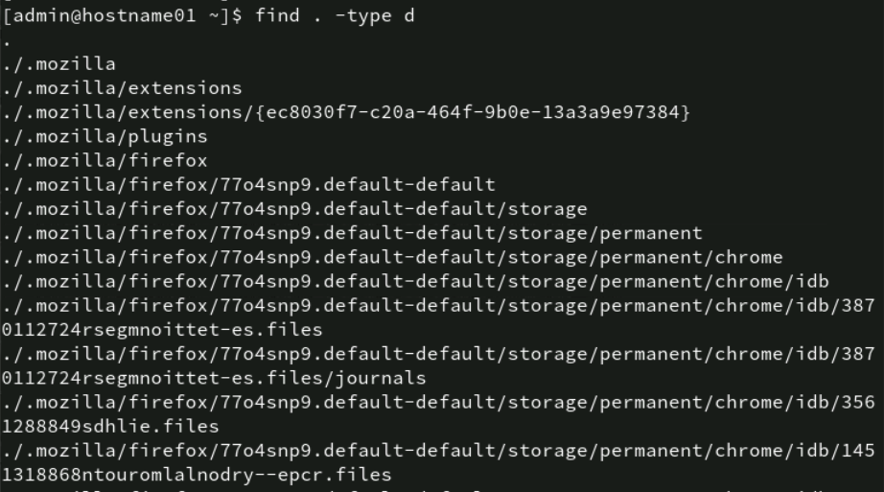

**11: Display the files starting with chap, along with its path.**

**12: Sort the file friends in ascending order of names.**

**[admin@hostname01 ~]$ sort -k1 friends.txt**

**13: Display the contents of the file friends in uppercase letters.**

**[admin@hostname01 ~]$ cat friends.txt | tr ‘a-z’ ‘A-Z’**

**14: Store the contents of your home directory in a file called dir.**

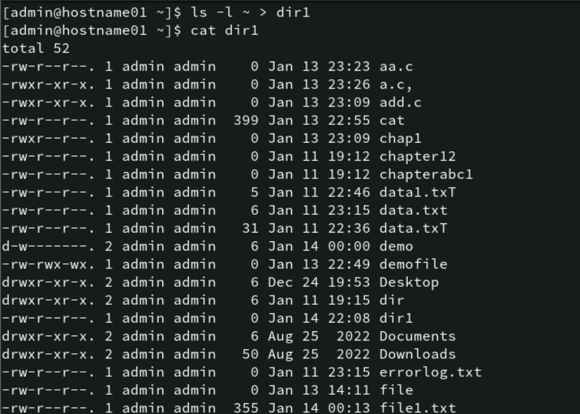

**15: From the above file dir, display the file permissions and the name of the file only.**

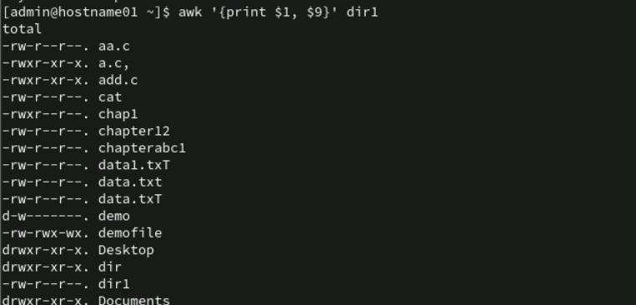

**16: From the same dir file, store only the file names in a file called files.**

**17: From the same dir file, store only the permissions of files in a file called perms.**

**18: From the same dir file, store only the file sizes in a file called sizes.**

**19: Display the file names, sizes and permissions from your directory in that order.**

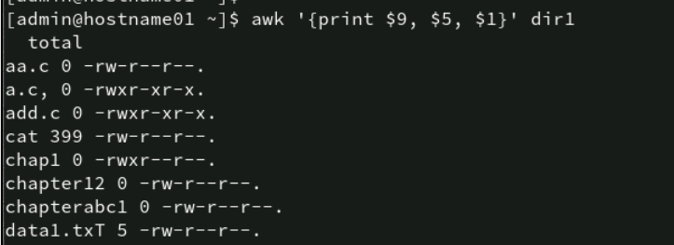

**20: Display the number of users working on the system.**



**21: Find out the smallest file in your directory.**



**22: Display the total number of lines present in the file friends.**

**[admin@hostname01 ~]$ wc -l friends.txt**

**23: Create the following fixed record format files (with “|” delimiter between fields) with the structure given below, and populate them with relevant data use these files to solve following questions**

**emp.lst: Empid(4),Name(18),Designation(9),Dept(10),Date of Birth(8),Salary(5)**

**dept.lst: Dept.Code (2), Name (10), Head of Dept’s id(4)**

**desig.lst: Designation Abbr.(2), Name (9)**

1. **Find the record lengths of each file.**

1. **Display only the date of birth and salary of the last employee record.**



**3. Extract only employee names and designations. (Use column specifications).**

**Save output as cfile1.**

**4. Extract Emp.id, dept, dob and salary. (Use field specifications). Save output as**

**cfile2.**

**5. Fix the files cfile1 and cfile2 laterally, along with the delimiter.**

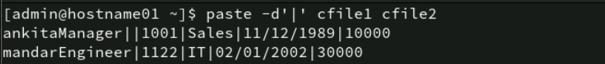

**6. Sort the emp.lst file in reverse order of Emp. Names.**

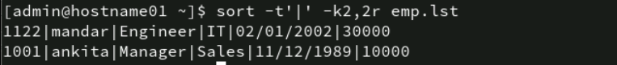

**7. Sort the emp.lst file on the salary field, and store the result in file srtf.**

**8. Sort the emp.ls t file on designation followed by name.**

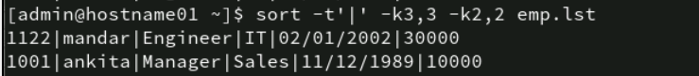

**9. Sort the emp.lst file on the year of birth.**

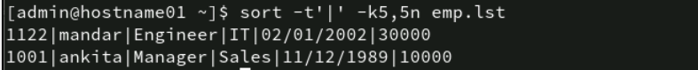

**10. Find out the various designations in the employee file. Eliminate duplicate**

**listing of designations.**



**11. Find the non-repeated designation in the employee file.**



**12. Find the number of employees with various designations in the employee file.**



**13. Create a listing of the years in which employees were born in, along with**

**number of employees born in that year.**

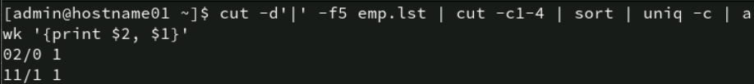

**14. Use nl command to create a code table for designations to include designation**

**code (Start with dept. code 100, and subsequently 105, 110 …).**



**24: PCS has its offices at Pune, TTC and Mumbai. The employees’ data is stored**

**separately for each office. Create appropriate files (with same record structure as**

**in previous assignment) and populate with relevant data.**

1. **List details about an employee ‘Manu Sharma’ in the Mumbai office.**



1. **List only the Emp.Id. And Dept. of Manu Sharma.**



1. **List details of all managers in all offices. (O/P should not contain file names.).**



1. **Find the number of S.E. in each office.**

**5. List only the Line Numbers and Employee names of employees in ‘H/W’ in**

**Pune file.**

**[admin@hostname01 ~]$ grep -n “H/W” Pune.txt | awk -F: ‘{print $1, $2}’ | awk ‘{print $1, $2, $3}’**

**6. Obtain a listing of all employees other than those in ‘HR’ in the Mumbai file**

**and save contents in a file ‘nonhr’.**

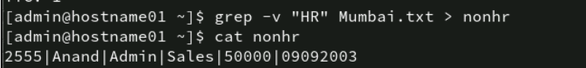

**7. Find the name and designation of the youngest person who is not a manager.**



**8. Display only the filename(s) in which details of employee by the name**

**‘Seema Sharma’ can be found.**



**9. Locate the lines containing saxena and saksena in the Mumbai office.**

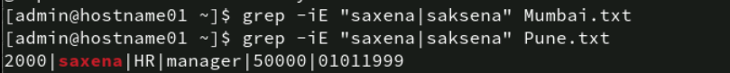

**10. Find the number of managers who earn between 50000 and 99999 in the Pune**

**office.**



**11. List names of employees whose id is in the range 2000 – 2999: in Pune**

**Office; in all offices.**

**12. Locate people having same month of birth as current month in Pune office.**



**13. List details of all employees other than those of HR and Admin in file F1.**

**14. Locate for all Dwivedi, Trivedi, Chaturvedi in Pune file.**

**15. Obtain a list of people in HR, Admin and Recr. depts. sorted in reverse order**

**of the dept.**



**25: Write a command sequence that prints out date information in this order: time,**

**day of week, day number, month, year :**

**13:44:42 IST Sun 16 Sept 1994**

**CA**

**26: Write a command sequence that prints the names of the files in the current**

**directory in the descending order of number of links.**

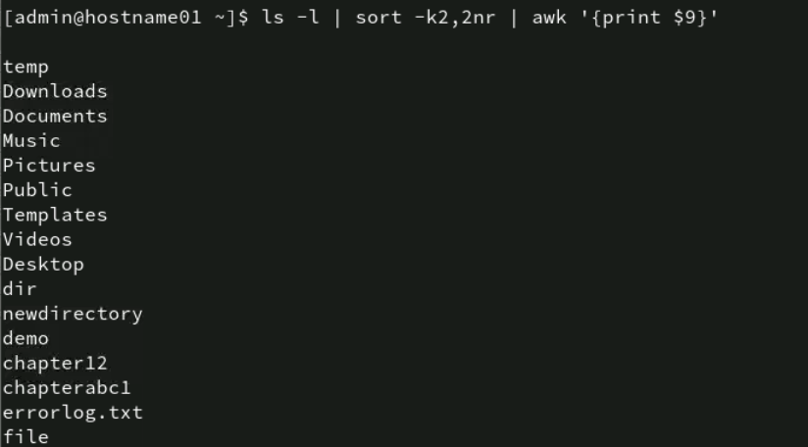

**27: Write a command sequence that prints only names of files in current working**

**directory in alphabetical order.**

**28: Write a command sequence to print names and sizes of all the files in current**

**working directory in order of size.**

**29: Determine the latest file updated by the user.**

